**CLASS DIAGRAM :-**

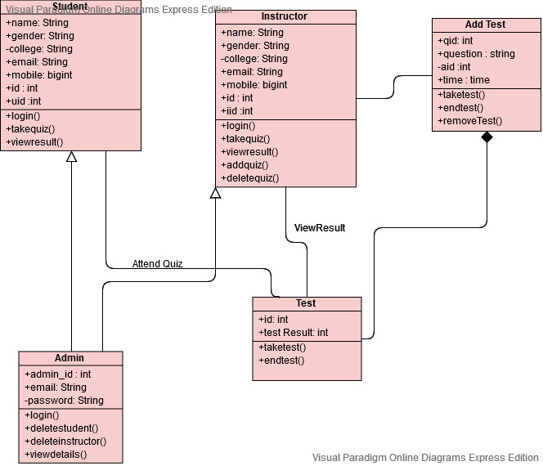

**USECASE DIAGRAM :-**

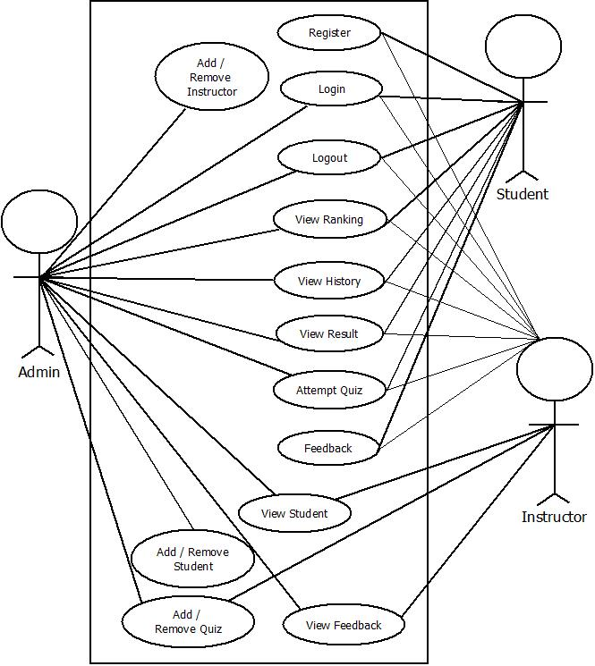

**SEQUENCE DIAGRAM :-**

**USER :-**

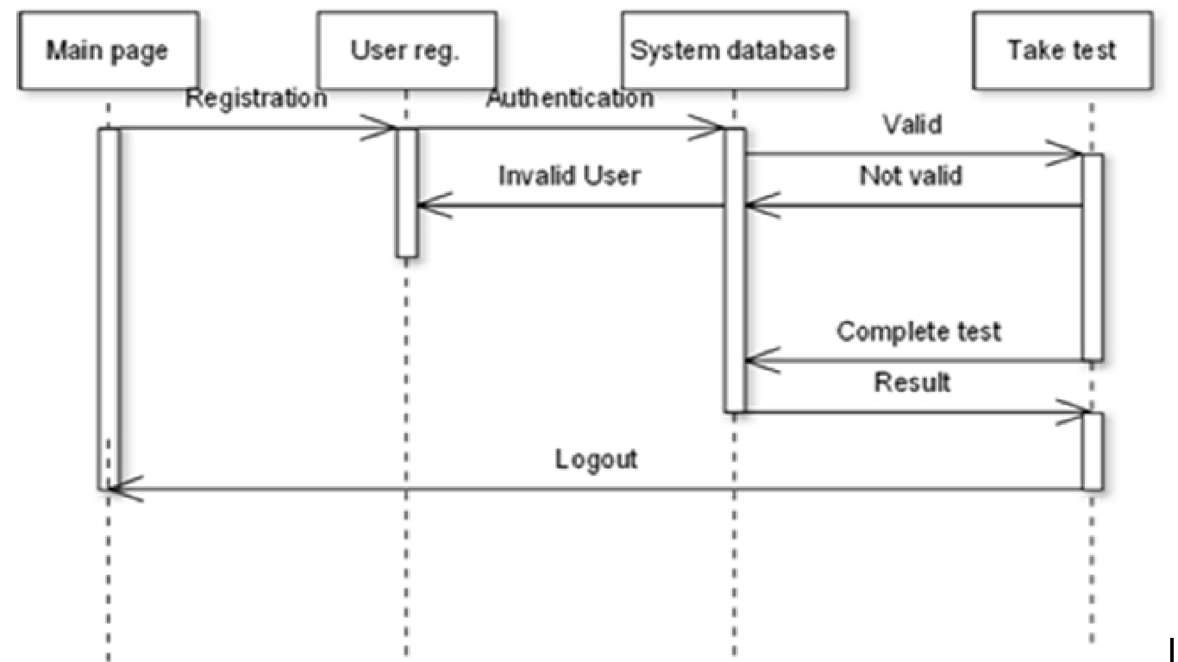

**INSTRUCTOR :-**

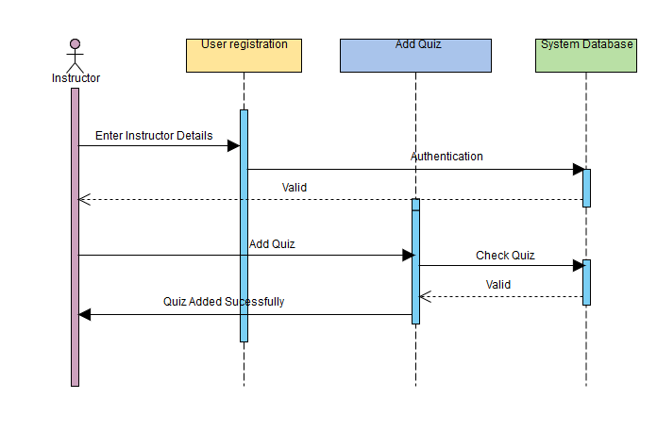

**DFD DIAGRAMS :-**

**DFD 0 :-**

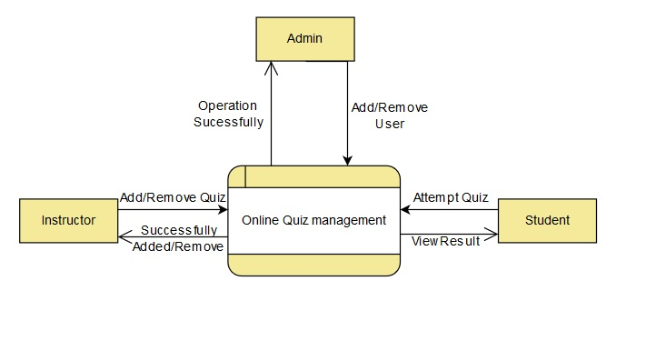

**DFD 1 ADMIN :-**

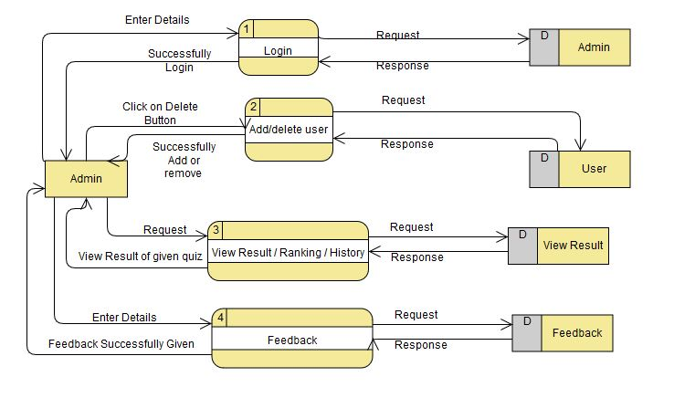

**DFD 1 INSTRUCTOR :-**

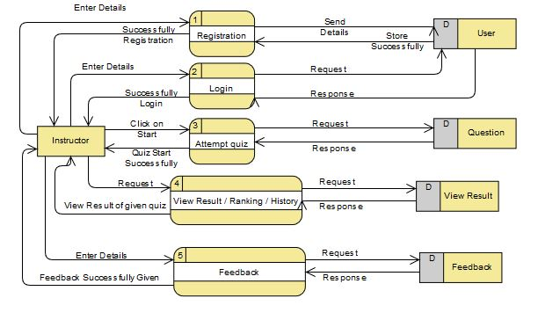

**DFD 1 STUDENT :-**

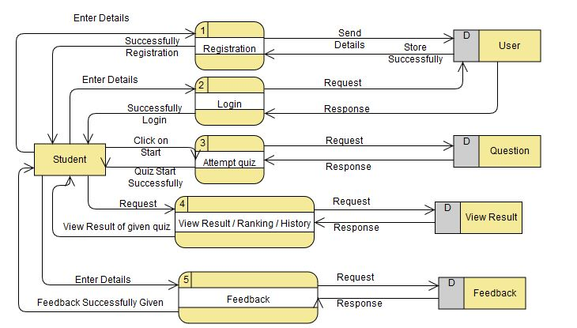

**DFD 2 ADMIN :-**

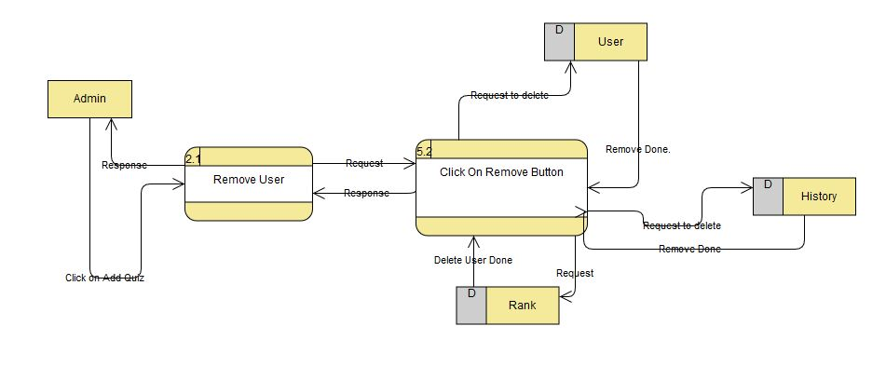

**DFD 2 INSTRUCTOR :-**

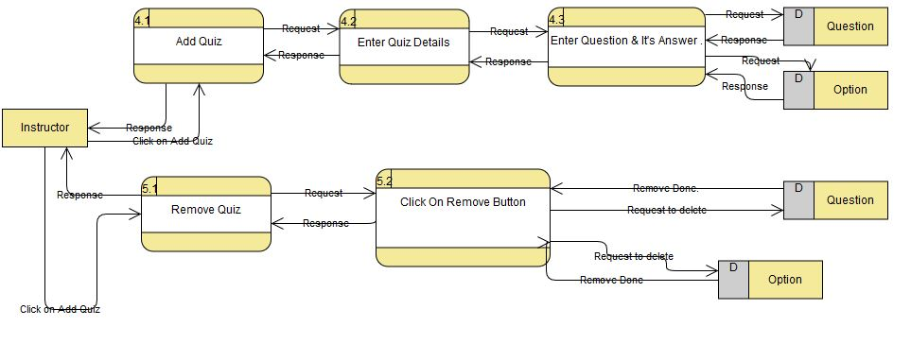

**ACTIVITY DIAGRAM :-**

**DATABASE TABLES :**

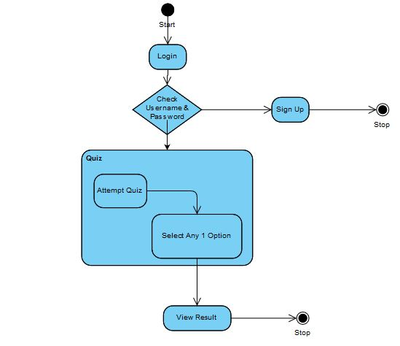

**User Table**

|  |  |  |  |  |  |
| --- | --- | --- | --- | --- | --- |
| **Sr. No.** | **Filed Name** | **Data Type** | **Size** | **Constraints** | **Description** |
| 1 | ID | INT | 10 | PRIMARYKEY | NOTNULL |
| 2 | NAME | VARCHAR | 50 | --- | --- |
| 3 | DOB | DATETIME | --- | --- | DATE OF BIRTH |
| 4 | GENDER | VARCHAR | 10 | --- | --- |
| 5 | COLLEGE | VARCHAR | 50 | --- | --- |
| 6 | UID | VARCHAR | 50 | --- | USER ID |
| 7 | PWD | VARCHAR | 20 | --- | PASSWORD |
| 8 | UTYPE | VARCHAR | 20 | --- | USER TYPE |

**Question Table**

|  |  |  |  |  |  |
| --- | --- | --- | --- | --- | --- |
| **Sr. No.** | **Filed Name** | **Data Type** | **Size** | **Constraints** | **Description** |
| 1 | ID | INT | 10 | PRIMARYKEY | NOTNULL |
| 2 | QUE | VARCHAR | 500 | --- | QUESTION |
| 3 | AW | VARCHAR | 500 | --- | ANSWER |

**Answer Table**

|  |  |  |  |  |  |
| --- | --- | --- | --- | --- | --- |
| **Sr. No.** | **Filed Name** | **Data Type** | **Size** | **Constraints** | **Description** |
| 1 | ID | INT | 10 | FOREIGNKEY | NOTNULL |
| 2 | AW | VARCHAR | 500 | --- | ANSWER |

**Rank Table**

|  |  |  |  |  |  |
| --- | --- | --- | --- | --- | --- |
| **Sr. No.** | **Filed Name** | **Data Type** | **Size** | **Constraints** | **Description** |
| 1 | ID | INT | 10 | --- | --- |
| 2 | MARKS | VARCHAR | 10 | --- | --- |

**Quiz Table**

|  |  |  |  |  |  |
| --- | --- | --- | --- | --- | --- |
| **Sr. No.** | **Filed Name** | **Data Type** | **Size** | **Constraints** | **Description** |
| 1 | QUIZ NAME | VARCHAR | 30 | --- | --- |
| 2 | QUIZ DATE | DATETIME | --- | --- | --- |

**Feedback Table**

|  |  |  |  |  |  |
| --- | --- | --- | --- | --- | --- |
| **Sr. No.** | **Filed Name** | **Data Type** | **Size** | **Constraints** | **Description** |
| 1 | ID | TEXT | 10 | --- | --- |
| 2 | NAME | VARCHAR | 50 | --- | --- |
| 3 | EMAIL | VARCHAR | 50 | --- | --- |
| 4 | SUBJECT | VARCHAR | 50 | --- | --- |
| 5 | FEEDBACK | VARCHAR | 500 | --- | --- |
| 6 | DATE | DATE | --- | --- | --- |
| 7 | TIME | VARCHAR | 50 | --- | --- |

**Admin Table**

|  |  |  |  |  |  |
| --- | --- | --- | --- | --- | --- |
| **Sr. No.** | **Filed Name** | **Data Type** | **Size** | **Constraints** | **Description** |
| 1 | ADMIN_ID | INT | 11 | PRIMARYKEY | AUTO INCREMENT |
| 2 | EMAIL | VARCHAR | 50 | --- | NULL |
| 3 | PASSWORD | VARCHAR | 50 | --- | NULL |